**Aim- to install NagiOS on Linux**

Login to Aws

Create Ec2 instances on Aws account of any linux os

Then Run the following command in SS

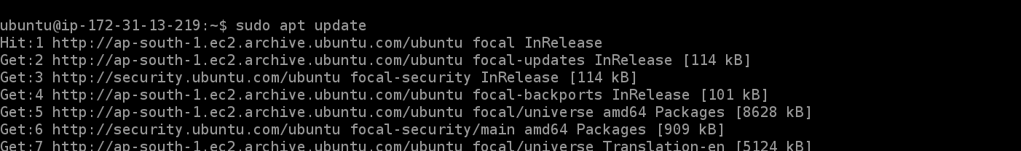

cd /usr/src/

sudo wget https://github.com/NagiosEnterprises/nagioscore/archive/nagios-4.4.2.tar.gz

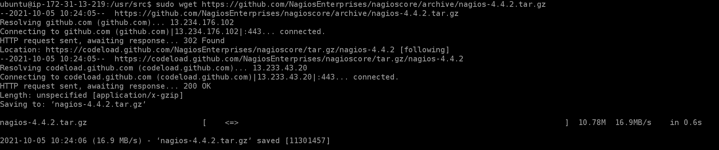

sudo tar zxf nagios-*.tar.gz

cd nagioscore-nagios-*/



Now finally run the following command

sudo ./configure --with-httpd-conf=/etc/apache2/sites-enabled

if error comes install c compiler on the linux

by following this link

<https://linuxize.com/post/how-to-install-gcc-compiler-on-ubuntu-18-04/>

Finally-

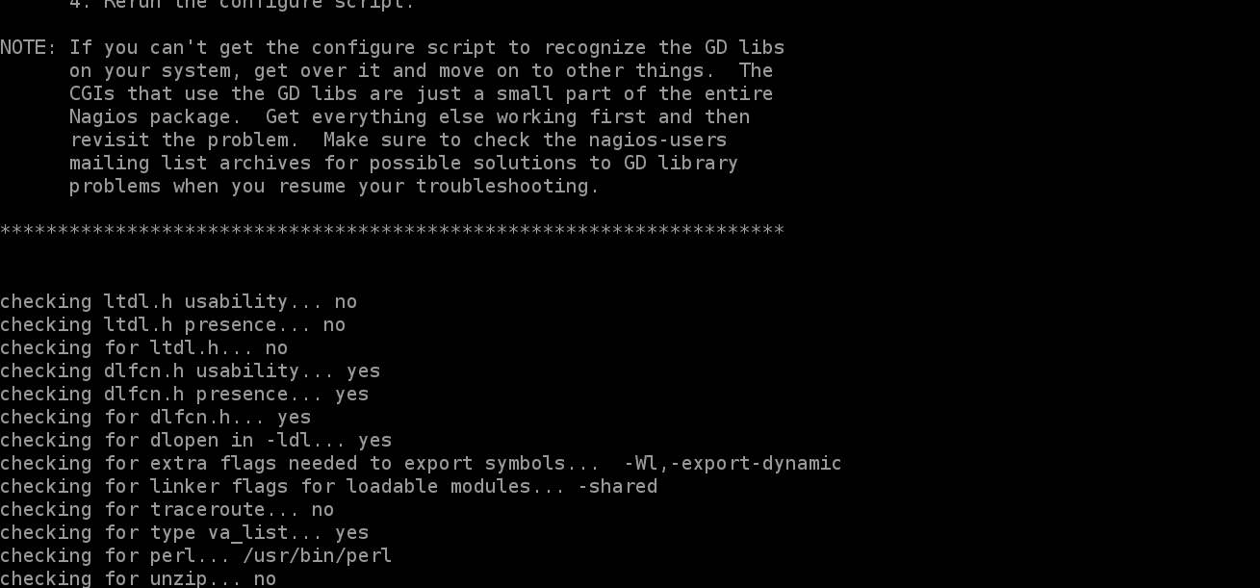

Now let us install plugins by

sudo wget -O nagios-plugins.tar.gz <https://github.com/nagios-plugins/nagios-plugins/archive/release-2.2.1.tar.g>

then

sudo tar zxf nagios-plugins.tar.gz

then

cd nagios-plugins-release-2.2.1

finally start and then check status of nagi os

sudo systemctl start nagios

sudo systemctl status nagios

